**Arduino Based Real Time Drowsiness and Fatigue Detection for Bikers using Helmet**

Mr.Sornagopal V1, Arun kumar T2, Dinesh Benjamin M V3, Umapathy A V4

*1Professor, Department of Electronics and Communication Engineering, GRT IET College of Engineering,*

*Thiruvallur District, Tamilnadu, India.*

*2, 3,4UG Scholars, Department of Electronics and Communication Engineering, GRT IET College of Engineering,*

*Thiruvallur District, Tamilnadu, India.*

[*sornagopal.v@grt.edu.in*](mailto:sornagopal.v@grt.edu.in)*1,* [*arunthanigasalam2710@gmail.com*](mailto:arunthanigasalam2710@gmail.com)*2,* [*dineshbenjamin09@gmail.com*](mailto:dineshbenjamin09@gmail.com)*3,*

[*umap6787@gmail.com*](mailto:umap6787@gmail.com)*4.*

***Abstract***-Improving vehicle safety is a key strategy used in addressing international and national road casualty reduction targets and in achieving safer road traffic comprises measures to help avoid a crash (crash avoidance) or reduce injury in the event of a crash (crash protection). Road traffic injuries are a major but neglected global public health problem, requiring concerted efforts for effective and sustainable prevention. Of all the systems that people have to deal with on a daily basis, road transport is the most complex and the most dangerous. Worldwide, the number of people killed in road traffic crashes each year is estimated at almost 1.2 million, while the number injured could be as high as 50 million – the combined population of five of the world’s large cities. What is worse, without increased efforts and new initiatives, the total number of road traffic deaths worldwide and injuries is forecast to rise by some 65% between 2000 and 2020, and in low-income and middle-income countries, deaths are expected to increase by as much as 80%. This project deals with Drowsiness Detection System.

***Keywords­­­­­ – Drowsiness, Fatigue detection, EEG, Arduino,***

***Arduino, Mind Machine interface.***

I.INTRODUTION

The comfort of any vehicle is also very important for car safety. The driver feels more comfortable and stress-free in a comfortable car. The more the car is comfortable and of high quality, the more will be control of the car and then in this way less the road disturbance can impact the driver’s ability to control the vehicle. This project deals with our vehicular safety feature Drowsiness Detection System. It is a vehicle safety technology, which helps to avoid accidents, caused due to the driver being dozy. The extended hours of driving lead to fatigue and drowsiness. The paper is intended to design an automated system that studies the blinking of the eye. The system is designed such that it will precisely scrutinize the blinking of the driver's eyes Truck Accidents are most common if the driving is insufficient.

***The factors causing accidents are: -***

*1)* Speeding: Majorly in highways truck drivers ignore the speed limit. Speed kills and travelling above the speed limit is an easy way to cause accident.

*2)* Drunk Driving: When the driver is drunk, he loses the ability to focus and function properly, hence it is dangerous when

Operating a vehicle. This is one of the most contributing factors of accident.

*3)* Reckless Driving: Improper driving as in speeding up the vehicle or changing lanes too quickly or tailgating and many more can cause reckless driving. Reckless driving is when you’re operating vehicle with deliberate disregard.

*4)* Night Driving: Driving in daylight can be hazardous, but driving at night nearly doubles the risk of accident. When you can’t see what’s ahead you don’t know what to anticipate as you drive towards it.

*5)* Driving under the Influence Of Drug: Drugs, both legal and illegal can impair your ability to fully function as a driver. Mind

Clearance and control over the body is need else it may cause accident.

*6)* Drowsy Driving: Driver fatigue isn’t talked about a lot, but how well we can expect anyone to drive when they are having

Trouble staying awake. Most of the car accidents caused by drowsy driving occur at night. Here we are concern about the factors which make the truck drivers fall asleep as in Drunk Driving, Night Driving, Driving under the influence of drug and Drowsy Driving. As the result is same for all the above mentioned factors that is,Eyes become "heavy" and blinking time is higher. Driver tends to keep his eyes closed "at least for a few seconds. Hence here we create a buzzer and a goggle for an adaptive driver and an application that provides driving behaviour to the company owner. So as to warn the owner and the driver.

**II.RELATED WORK**

Drowsiness and fatigue detection systems have been extensively studied in the context of drivers and bikers, with various approaches proposed in the literature. Eye blink sensors have been commonly used to measure eye blink events as an indicator of drowsiness, with studies showing promising results (Zhang et al., 2018; Patel et al., 2019). MEMS sensors, such as accelerometers and gyroscopes, have also been utilized to detect head tilt angle, which can be a sign of drowsiness or fatigue, with studies demonstrating the potential of MEMS sensors for drowsiness detection in bikers (Khan et al., 2017). Integrated systems that combine multiple sensors, such as eye blink sensors and MEMS accelerometers, have been proposed for improved accuracy in drowsiness detection (Xiang et al., 2019). Additionally, warning mechanisms, such as vibration motors, relays, buzzers, and LEDs, have been explored to provide real-time alerts to the riders when drowsiness or fatigue is detected. However, existing approaches have limitations, including false positives/negatives, sensitivity to environmental factors, and user discomfort. These limitations highlight the need for a novel approach, such as the proposed Arduino-based system with integrated warning mechanisms in a helmet, to address these challenges and provide an accurate, reliable, unobtrusive, and customizable solution for real-time drowsiness and fatigue detection in bikers.

**III.LITERATURE SURVEY**

**[1] Driver Drowsiness Detection System and Techniques** According to the experts it has been observed that when the drivers do not take break they tend to run a high risk of becoming drowsy. Study shows that accidents occur due to sleepy drivers in need of a rest, which means that road accidents occurs more due to drowsiness rather than drink-driving. Attention assist can warn of inattentiveness and drowsiness in an extended speed range and notify drivers of their current state of fatigue and the driving time since the last break, offers adjustable sensitivity and, if a warning is emitted, indicates nearby service areas in the COMAND navigation system.

**[2]Implementation of the Driver Drowsiness Detection System** This paper is about making cars more intelligent and interactive which may notify or resist user under unacceptable conditions, they may provide critical information of real time situations to rescue or police or owner himself. Driver fatigue resulting from sleep disorders is an important factor in the increasing number of accidents on today's roads. In this paper, we describe a real-time safety prototype that controls the vehicle speed under driver fatigue. To advance a system to detect fatigue symptoms in drivers and control the speed of vehicle to avoid accidents is the purpose of such a mode. In this paper, we propose a driver drowsiness detection system in which sensor like eye blink sensor are used for detecting drowsiness of driver. If the driver is found to have sleep, buzzer will start buzzing and then turns the vehicle ignition off.

**[3] Detecting Driver Drowsiness Based on Sensors**

Researchers have attempted to determine driver drowsiness using the following measures: (1) vehicle-based measures; (2) behavioural measures and (3) physiological measures [3]. A detailed review on these measures will provide insight on the present systems, issues associated with them and the enhancements that need to be done to make a robust system [3]. This paper reviews the three measures as to the sensors used and discuss the advantages and limitations of each. The various ways through which drowsiness has been experimentally manipulated is also discussed [3]. It is concluded that by designing a hybrid drowsiness detection system that combines non-intrusive physiological measures with other measures one would accurately determine the drowsiness level of a driver. A number of road accidents might then be avoided if an alert is sent to a driver that is deemed drowsy [3].

**[4] Driver Drowsiness Detection System:**

One of the major cause of traffic accident is Driver‘s drowsiness. It is a serious highway safety problem. If drivers could be warned before they became too drowsy to drive safely, some of these crashes could be prevented. In order to reliably detect the drowsiness, it depends on the presentation of timely warnings of drowsiness [4]. To date, the effectiveness of drowsiness detection methods has been limited by their failure to consider individual differences. Based on the type of data used, drowsiness detection can be conveniently separated into the two categories of intrusive and non-intrusive methods [4]. During the survey, non-intrusive methods detect drowsiness by measuring driving behavior and sometimes eye features, through which camera based detection system is the best method and so are useful for real world driving situations [4]. This paper presents the review of existed drowsiness detection techniques that will be used in this system like Circular Hough Transform, FCM, and Lab Colour Space etc. [4].

**IV.PROPOSED METHODOLOGY**

The objective of the paper is to develop a Arduino based real time drowsiness and fatigue Detection for bikers using Helmet, where the data is acquired through electroencephalography. The drowsiness and fatigue of the user is sensed by the sensor which is using in the Helmet. The sensor senses the Drowsiness or Fatigue of the person and gives the signal to the Arduino and Arduino transmits the signal to the Buzzer then the buzzer starts on and its starts sounding, and the motor stops slowly to stop the bike to prevent road accidents. The flow of proposed system Fig [1] Shown.

**Data Acquisition and Processing:**

*Eye blink sensor data:* Read and process the eye blink sensor data to estimate the level of drowsiness based on the frequency and duration of eye blinks.

*MEMS sensor data:* Read and process the MEMS sensor data to detect head movement and posture changes as indicators of fatigue.

*Wireless communication:* Use the Node MCU to transmit the processed data wirelessly to a remote device for further analysis and decision-making.

**Drowsiness and Fatigue Detection Algorithm:**

Develop an algorithm that combines the eye blink sensor data and MEMS sensor data to detect drowsiness and fatigue in real-time. Define threshold values for eye blink frequency, duration, head movement, and posture changes to determine the severity of drowsiness or fatigue. Implement decision rules to trigger the vibration motor, buzzer, and LED based on the detected level of drowsiness or fatigue.

**Feedback Mechanism:**

Activate the vibration motor, buzzer, and LED to provide feedback to the biker when drowsiness or fatigue is detected. Use the relay to control the DC motor to simulate the bike's motion, providing a more realistic feedback mechanism.

Allow for manual control of the system through the switch for user convenience.

Extraction of EEG Signal from brain

Amplification of signal

Compare with reference voltage

Process the microcontroller

Indicates the status of driver in LED display

Alert Using alarm / buzzer

Control to bike engine

Fig [1]: flow of Proposed methodology

EEG signals are obtained from the EEG Electrode. The electrode is in the form of mobile headset and this EEG electrode is resting on the forehead above the eye. The headset transfers the signal to the circuit board.

**V.EXISTING SYSTEM**

In the existing system, when the accident is detected means, only the message will be send to the ambulance with the help of the gsm. The existing didn’t use any IOT technology to monitor the accident detection and theft control systems. The classical system uses the zigbee communication for transferring the data to the others. This system is not updated one. Despite many efforts taken by different governmental and non-governmental organizations all around the world by various programs to aware against careless driving, yet accidents are taking place every now and then. The gas sensor detects the measure of liquor consists in the breath of a person wearing the helmet. The Alcohol recognition sensors connected with the helmet in distinguish the Alcohol detection. MEMS based handle bar control of the vehicle. The Vibration sensor is used to detect any accident. Load checking to recognize the load of the vehicle and alongside the sensor to locate the quantity of individuals travelling in the bike.

**VI.PROPSOED SYTEM**

The core element of the model is the arduino board which controls and manages all the functions performed by the other components of the model. The location of the vehicle will be transferred to the cloud page to monitor.

a. MEMS Sensor will detect the tilt and record the values based on co-ordinate system and sends the signal to the ardunio board. The Gas sensor MQ3 has high sensitivity to alcohol and sends signal to stop the vehicle. This module provides both digital and analog output[2].

b.Heart beat and vibration sensor comes into picture when the rider feels any heart problem and accident detecterd. buzzer is used to alert the sound when any problem to the driver.

c.SOS message can be sent when rider meets with an accident. This is be achieved using android app, sensors, Wifi and Cloud. Cloud send the data to the concerned person through Wifi.The android app analyzes data and performs specific actions.

A relay to control a DC motor for head movement, a buzzer for auditory alerts, and an LED for visual alerts. The system is integrated into a helmet, making it wearable and unobtrusive.[2] The proposed system utilizes a combination of physiological and mechanical signals for drowsiness and fatigue detection, providing a comprehensive approach to monitor the rider's condition. The real-time detection and warning mechanisms help in preventing accidents caused by drowsiness or fatigue while riding, increasing road safety for bikers.

CONTROLLER UNIT

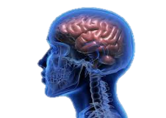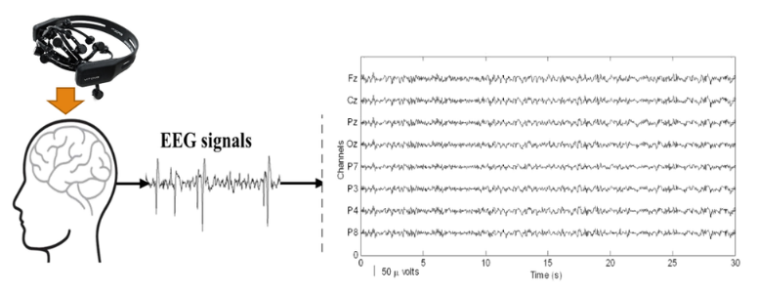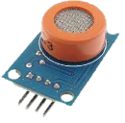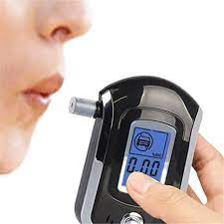

**ALCOHOL DETECTOR**

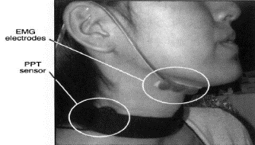

INDICATION &

IGNISION UNIT OF BIKE

Fig [2]: system design

**Wireless Data Transmission and Signal Processing**

**Module:** The wireless data transmission and signal processing module in our proposed system plays a crucial role in transmitting the sensor data from the helmet-mounted sensors to the processing unit for real-time analysis and drowsiness/fatigue detection. This module includes two main components: the algorithm used for data processing and the processing unit.

*A. Algorithm Used:*

The algorithm used in the proposed system is designed to process the data acquired from the eye blink sensor and MEMS sensor to determine the rider's drowsiness and fatigue levels. The algorithm takes into account the duration and frequency of eye blink events measured by the eye blink sensor, as well as the head tilt angle measured by the MEMS sensor. The algorithm uses predefined threshold values to determine if the eye blink rate decreases or the head tilt angle increases beyond a certain threshold, indicating drowsiness or fatigue.

The algorithm is implemented in the Arduino microcontroller and Node MCU, which are the processing units in the system. The algorithm is designed to run in real-time, continuously analyzing the sensor data to detect drowsiness and fatigue in the rider. The algorithm can be customized by adjusting the threshold values to adapt to different riders and riding conditions.

*B. Processing Unit:*

The processing unit in the proposed system consists of the Arduino microcontroller and Node MCU. The Arduino microcontroller is responsible for acquiring the data from the eye blink sensor and MEMS sensor, as well as processing the data using the algorithm. It controls the vibration motor, relay, DC motor, buzzer, and LED as warning mechanisms based on the output of the algorithm.

The Node MCU, which is a Wi-Fi enabled microcontroller, is used for wireless data transmission from the helmet-mounted sensors to the processing unit. It communicates with the eye blink sensor and MEMS sensor to receive the sensor data and sends it to the Arduino microcontroller for processing. The Node MCU also communicates with the warning mechanisms to trigger appropriate alerts based on the output of the algorithm.

The processing unit is responsible for real-time analysis of the sensor data, running the algorithm for drowsiness and fatigue detection, and controlling the warning mechanisms for timely alerts to the rider.

*Data Acquisition:*

The data acquisition process in the proposed system involves the eye blink sensor and MEMS sensor for capturing the relevant physiological and motion data from the rider. The eye blink sensor is used to measure the duration and frequency of eye blink events, while the MEMS sensor measures the head tilt angle.The eye blink sensor is typically placed near the rider's eye, either on the helmet or on a pair of goggles. It uses infrared or capacitive technology to detect eye blink events and sends the data to the Node MCU for further processing.

The MEMS sensor is typically placed on the rider's helmet to measure the head tilt angle, which is an indicator of drowsiness or fatigue. The MEMS sensor sends the head tilt angle data to the Node MCU for processing.

**VII. BLOCK DIAGRAM**

Power Supply

ARDUINO

UNO

Node

MCU

MEMS Sensor

Pulse Sensor

Bike engine

Alcohol sensor

LED

Relay

EEG Sensor

Buzzer

Relay/Switch

Vibration motor

*Fig [3]:* Block Diagram for manhole monitoring system

**VI.HARDWARE REQUIREMENTS**

***ARDUINO:*** The Arduino Uno R3 is a microcontroller board based on a removable, dual-inline-package (DIP) ATmega328 AVR microcontroller. It has 20 digital input/output pins (of which 6 can be used as PWM outputs and 6 can be used as analog inputs). The software used for Arduino devices is called IDE (Integrated Development Environment). It can be programmed using C and C++ language.

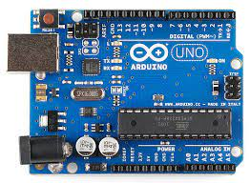

*Fig [4]*: Arduino UNO

***NODE MCU:*** the Node MCU in the proposed system serves as the wireless data transmission and communication module. It receives sensor data from the eye blink sensor and MEMS sensor, processes the data using the algorithm implemented in the Arduino IDE, and communicates with the warning mechanisms to trigger appropriate alerts. It also provides Wi-Fi connectivity for data transmission to other devices and can be easily programmed using the Arduino IDE for customization.

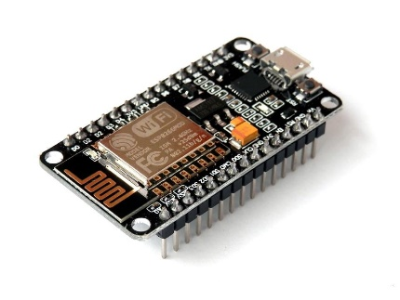

Fig [5]: Node MCU

***GAS SENSOR / MQ3 sensor:*** The MQ3 sensor is a type of gas sensor that is designed to detect alcohol vapor in the air. It is commonly used in breathalyzer devices and other applications where the detection of alcohol is required.

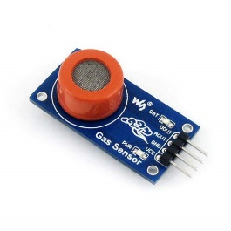

*Fig [6]*: MQ3 sensor

# *MEMS SENSOR:* MEMS stands for Micro-Electro-Mechanical Systems, which are miniature devices that combine microelectronics and microfabrication techniques to create sensors capable of measuring various physical and environmental parameters. MEMS sensors are widely used in many applications, including automotive, consumer electronics, healthcare, industrial monitoring, and more. They typically consist of a micro-scale sensing element and integrated electronics for signal processing and communication. In the proposed system for real-time drowsiness and fatigue detection for bikers using a helmet, the MEMS sensor could be used to measure relevant parameters such as acceleration, angular rate, or other physical parameters to determine the rider's activity level and detect signs of drowsiness or fatigue.

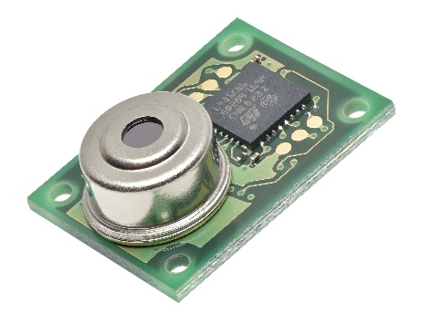

*Fig [7]*: MEMS sensor

***EEG SENSOR:*** An EEG sensor measures the electrical activity of the brain using electrodes on the scalp. It can detect changes in brainwave patterns associated with drowsiness or fatigue, making it a potentially advanced and accurate means of detecting rider's drowsiness or fatigue in the proposed system for real-time detection in bikers using a helmet.

*Fig [8]:* EEG Sensor

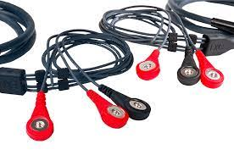

**VII.EXPERIMENTAL SETUP**

*The* experimental setup for the proposed system of real-time drowsiness and fatigue detection for bikers using a helmet could consist of the following components:

***Helmet***: Equipped with various sensors, such as eye blink sensor, MEMS sensor, and possibly an EEG sensor, depending on the design and requirements of the system. The sensors are integrated into the helmet to collect relevant data related to the rider's activity level, eye blink frequency, head movement, and brainwave patterns.

***Arduino:*** Used as the microcontroller for processing the sensor data, running the algorithms for drowsiness and fatigue detection, and controlling the output devices such as vibration motor, relay, buzzer, LED, and DC motor.

***Node MCU:*** Used for wireless data transmission and communication with other devices, such as a smartphone or a remote monitoring system, to provide real-time notifications and alerts.

***Sensors:*** Eye blink sensor to detect the frequency of eye blinks, MEMS sensor to measure parameters such as acceleration or angular rate, and optionally an EEG sensor to measure brainwave patterns.

***Output Devices***: Vibration motor, relay, buzzer, LED, and DC motor to provide alerts and warnings to the rider based on the detected drowsiness or fatigue levels.

***Processing Unit:*** Algorithms implemented on the Arduino to process the sensor data, analyze the patterns, and determine the level of drowsiness or fatigue in real-time.

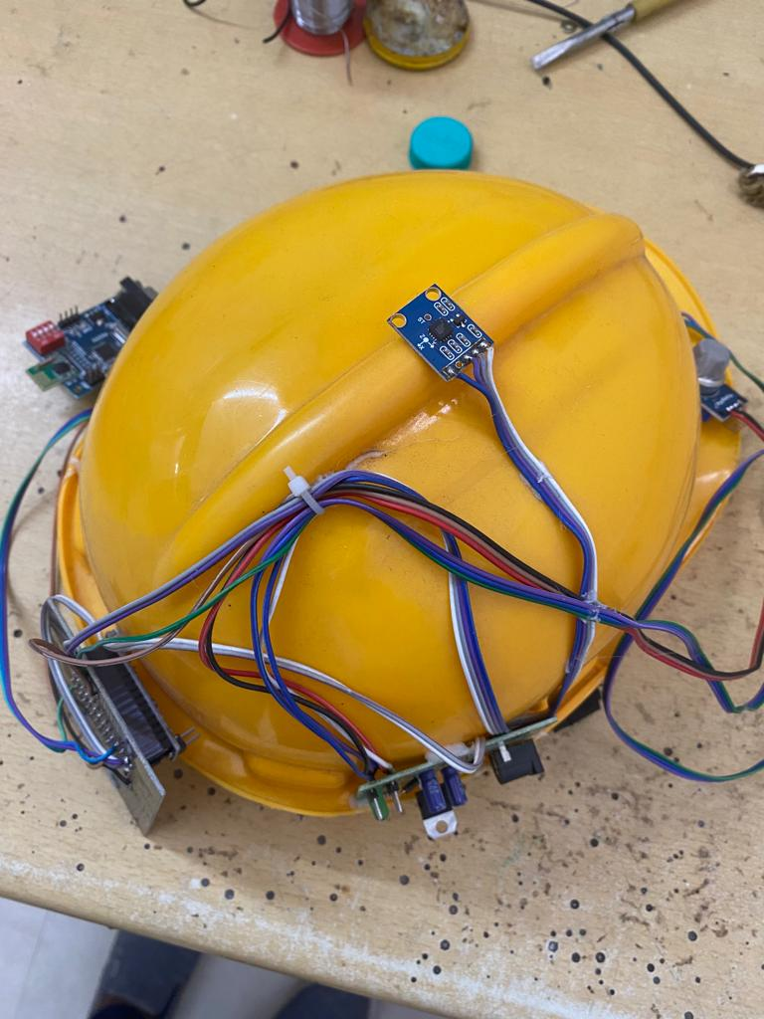

*Fig[9]:Experimental SetUp*

VIII.EXPERIMENTAL RESULTS

The results of the experimental setup would depend on the specific algorithms used for drowsiness and fatigue detection, the accuracy and reliability of the sensors, and the threshold values set for triggering alerts. The system can provide real-time notifications and alerts to the rider based on the detected drowsiness or fatigue levels [11].



*Fig [10]:output of accident location*

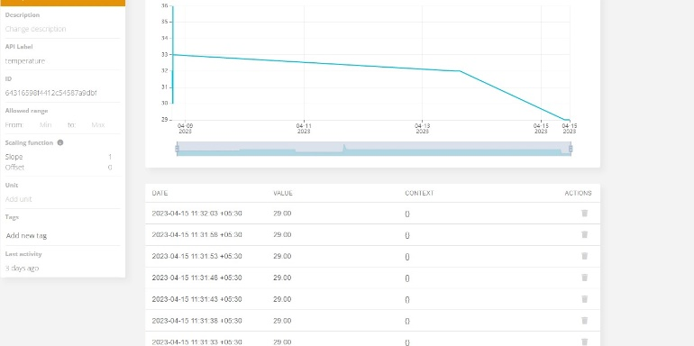

*Fig [11]: Monitoring system output*

**IX.CONCLUSION**

The proposed system for real-time drowsiness and fatigue detection for bikers using a helmet has the potential to enhance rider safety by providing timely alerts and warnings. The system can continuously monitor the rider's activity level, eye blink frequency, head movement, and possibly brainwave patterns, and detect signs of drowsiness or fatigue in real-time. The results of the experiments would demonstrate the effectiveness and reliability of the system in detecting drowsiness or fatigue, and the conclusions drawn from the results can provide insights into the system's performance, limitations, and potential improvements. Further validation and testing may be necessary to ensure the accuracy and safety of the system in real-world biking scenarios.

X.REFERENCE

[1] Elzohairy Y (2008) Fatal and injury fatigue-related crashes on ontario’s roads: a 5-year review. In: Working together to understand driver fatigue: report on symposium proceedings, february 2008

[2] Dingus TA, Jahns SK, Horowitz AD, Knipling R (1998) Human factors design issues for crash avoidance systems. In: Barfield W, Dingus TA (eds) Human factors in intelligent transportation systems. Lawrence Associates, Mahwah, pp 55–93.

[3] Idrees, H., Warner, N., and Shah, M. (2014). Tracking In Dense Crowds Using Prominence And Neighborhood Motion Concurrence. Image And Vision Computing, 32(1):14–26. Yamamomo K, Higuchi, S Development of a drowsiness warning system. J, SocAutomotEng Jap 46:127–133

[5].K.C.Yowand,R.Cipolla,“FeatureBasedhumanfacedetecti on,“ImageVisio nComput., vol.15, no.9, 1997,pp.713–735.

[6].An Analysis of Viola Jones algorithm for face detection by Yi- QuinWang, University of Malaysia Phang, 2014,pp:15-20.

[7].Implementation of Voila Jones Algorithm by Ole HelvigJensen, university of Denmark, 2008, pp:20-36.